In situ observation of Theophylline anhydrous forms II, III, V, and I* using Variable-Temperature, Variable-Relative Humidity Powder X-ray Diffraction
Stephan X.M. Boerrigter and Blaise A.F. Mibeck, Triclinic Labs.
Theophylline was investigated using an Anton Paar Controlled Humidity Chamber (CHC+) attachment on a Rigaku SmartLab powder diffractometer to observe polymorphic transitions as a function of temperature and relative humidity. The experiments resulted in the observation of Forms II, III, V, and I*. The results demonstrate that VT,VRH-PXRD is a powerful and relatively effective technique to discover polymorphs involved in phase transitions and explore the thermodynamic temperature–relative humidity phase diagram.
Keywords:Theophylline, temperature, relative humidity, powder X-ray diffraction, polymorphism, phase transition.

Introduction
Theophylline is a well-known active pharmaceutical ingredient (API) used as a bronchodilator for the treatment of asthma and Chronic Obstructive Pulmonary Disease (COPD). Anhydrous theophylline has been crystallized in many different packing arrangements, designated as polymorphs I through VII [1–9]. In addition to the pure compound, theophylline can also incorporate water into its crystal lattice to form a monohydrate [10]. Form II (FII) is the most commonly encountered form and was long thought to be the most stable form at room temperature [3]. The latest-discovered form, FIV, which only crystallizes from FII under solvent-mediated conditions is now believed to be the most stable at room temperature [3]. When exposed to high water activity, FII readily converts to the monohydrate (Fm). However, when heated to remove the water, Fm has been observed to first convert to a form named I* immediately followed by the conversion to FII [1]. Form I* is classified as a dehydrated-hydrate. Others have called it Form III and shown to have the same structure as Fm, but with the water molecules removed [5]. As such, FIII is meta-stable at room temperature and ambient relative humidity [6]. Due to its transient nature, the crystal structure of FIII was difficult to determine and was mostly derived from computational studies. Here, we use Variable Temperature, Variable Relative Humidity Powder X-ray Diffraction (VT/VRH-PXRD) to investigate the conversion kinetics involving FIII.

Variable Temperature Powder X-ray Diffraction at Controlled Relative Humidity
A sample of theophylline Fm was generated overnight by slurrying FII (Spectrum lot 2IF0334) in water at 55 °C and subsequently air-drying the solid fraction. An Anton Paar Cryo & Humidity Chamber (CHC+) system was interfaced to a Rigaku SmartLab powder X-ray diffractometer to perform in-situ powder X-ray diffraction of the dehydration of Fm.
Fm was heated from 5 to 80 °C under constant relative humidities of 5%, 50%, and 75%. PXRD patterns were collected in the 2θ range of 5° to 20° every seven minutes.
Figure 1 shows a waterfall plot of the heating experiment at 5% RH. The sets of peaks belonging to known forms are marked in the plot in the approximate range in which they were observed. The onset temperature at which each form was first observed is indicated on the right. The experiment started with pure Fm. At 10 °C a set of peaks was observed to emerge at 2θ angles of 9.4°, 12.5°, 13.7°, and 15.3°. This set of peaks matches the dehydrated-hydrate form I* reported by Phadnis [1]. At 30 °C a new set of peaks emerged that could be attributed to FIII [6]. At 50 °C the peaks attributed to the stable anhydrous form II started to appear. Before the final temperature of 80 °C was reached, the peaks of I* had completely diminished resulting in a mixture of forms II and III at the end of the experiment.
Form I* remains an unsolved crystal structure at the present time. Interestingly, a short-lived intermediate form, “T1”, was predicted from the same molecular dynamics study that resulted in Form III [6]. Given the calculated unit cell parameters for this putative intermediate form, the diffraction (2θ) angles are at 5.8°, 6.7°, 8.9, 11.6, 13.4°, etc. These peak positions do not resemble the observed peaks. Therefore, Form I* does not have the crystal structure predicted as T1.
At 30 °C the first peaks attributed to the metastable form III emerged. Form II was first observed at 50 °C. At that temperature the peaks belonging to the unknown phase had diminished. At the end of the experiment a mixture of forms II and III remained. Various researchers have shown that form III will convert to form II if the sample is heated to higher temperatures [1, 4, 11] or kept at typical ambient relative humidity for several days [1].
Larsen et al. equated form III and I* to one and the same form. Although most of the I* peaks are close to those of form III, we believe this interpretation to be incorrect because form III does not account for the observed Bragg peak at 12.5°. The peak at 12.5° is close to the Form II peak at 12.7°, and it could be argued the peak morphed into that peak. However, this is not likely because we observed the two distinct peaks concomitantly for a brief time during the experiment, as evidenced by the overlapping temperature range of the respective peaks. Furthermore, if the peak at 12.5° was attributable to form II instead of III, it would not have started to appear concurrently at 10 °C with the other three peaks. Therefore, we conclude that I* is a distinctly different phase from forms II and III.
Figure 1. Theophylline monohydrate heated from 7 to 80 °C at 5% RH. Blue: characteristic peaks for Fm, Green: FI*, Red: FIII, Violet: FII.
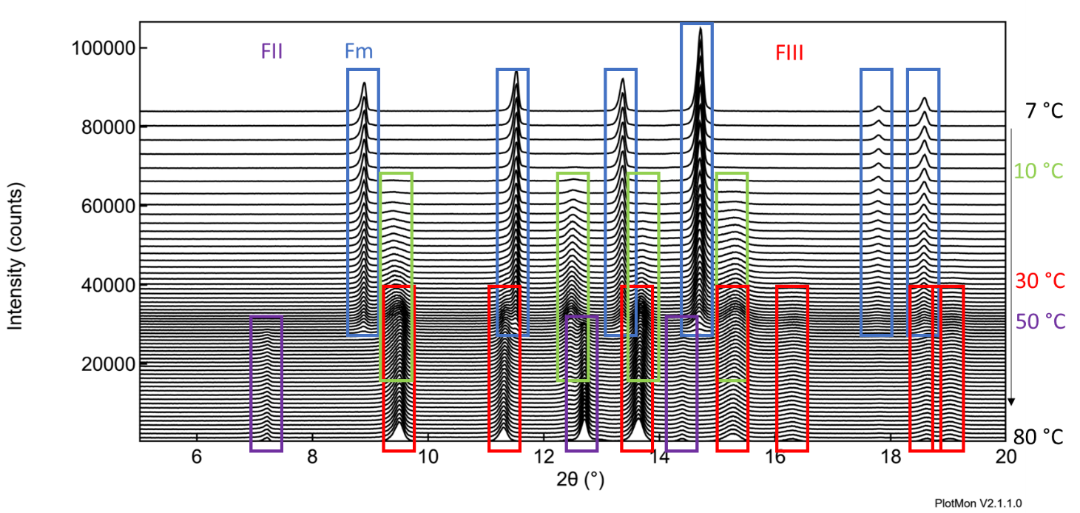

The heating experiment of theophylline monohydrate was repeated at 50% RH. Figure 2 shows the waterfall plot. At this relative humidity, the transition from the monohydrate to form II was observed to initiate at 50 °C and continued more rapidly at 60 °C. There were neither signs of the transient form (I*) nor of form III. Upon close inspection of the baseline, additional scattering intensity was observed at 13°. The only Bragg angle that could explain this intensity was of form V [7]. A corresponding intensity at 6.9° can be observed as well. Note that the peaks for form V start to appear almost simultaneously with the form II peaks. Figure 3 shows a detail of the transition at 50 °C and 60 °C in overlay with reference patterns for Forms Fm, FII, and FV.
Figure 2. Theophylline monohydrate heated from 20 to 80 °C at 50% RH. Blue: characteristic peaks for Fm, Violet: FII.
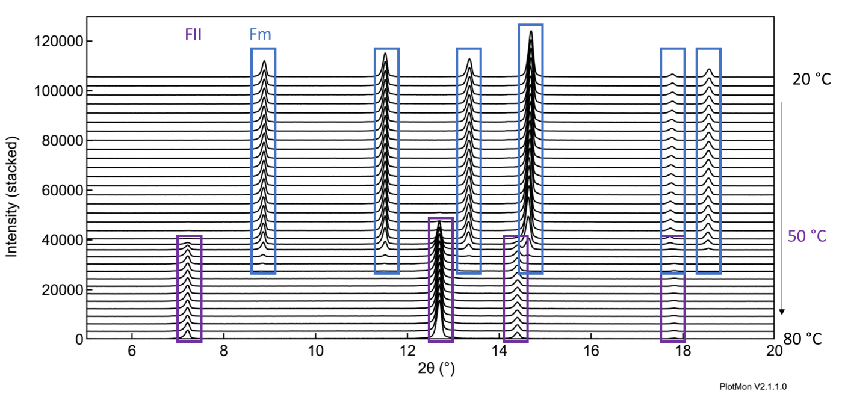
Figure 3. Detail of the form transition at 50% RH in overlay with several reference patterns. Blue: Fm, Violet: FII, Pink: FV.
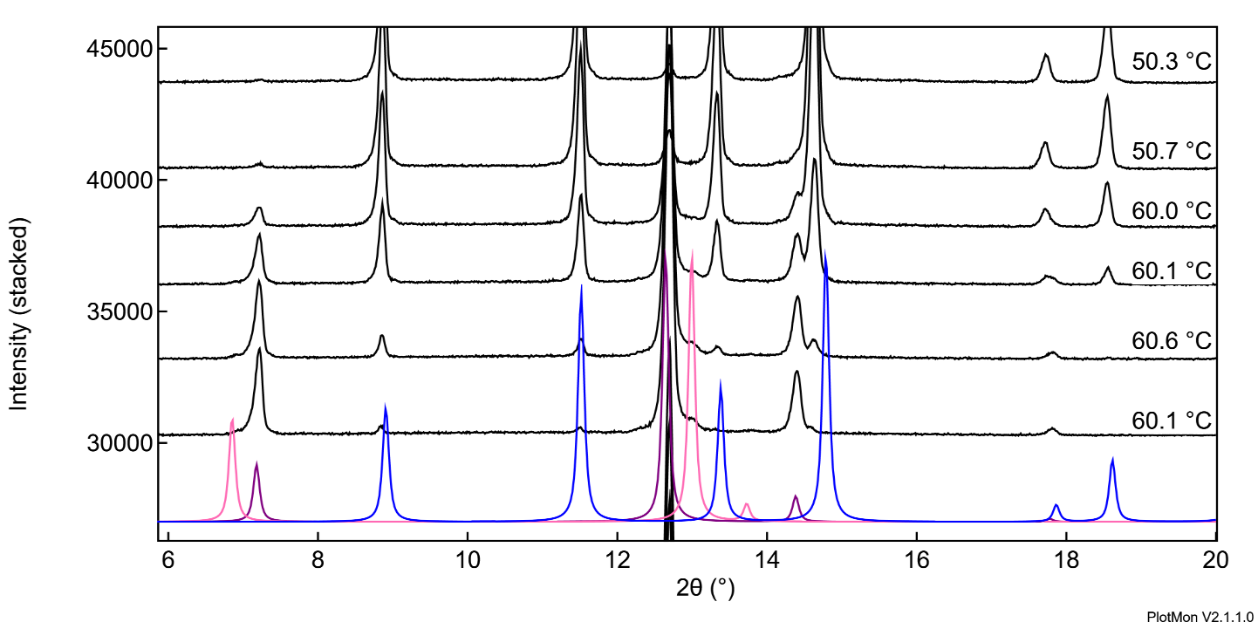

Form V was serendipitously discovered from a chemical reaction [7]. Effectively, the crystallization conditions were from the chemical reaction mixture with DMF, water and methanol as solvents. The hot mixture (100 °C) was crash-cooled, filtered and the solvent was evaporated. Interestingly, form V crystallized concomitantly with a theophylline cocrystal. The conditions at which form V was observed here were obviously very different.
A third experiment to dehydrate theophylline monohydrate was performed at 75% RH, again at increasing temperatures from 20 to 80 °C. The waterfall plot looked very similar as that of the experiment performed at 50% RH with the exception that the transition initiated at 60 °C and completed much faster. The final result was again a mixture of forms II and V, but form V was much more abundant; see Figure 4.
Figure 4. The final PXRD pattern collected at 80 °C and 75% RH. Black: experimental, violet: form II, pink: form V.
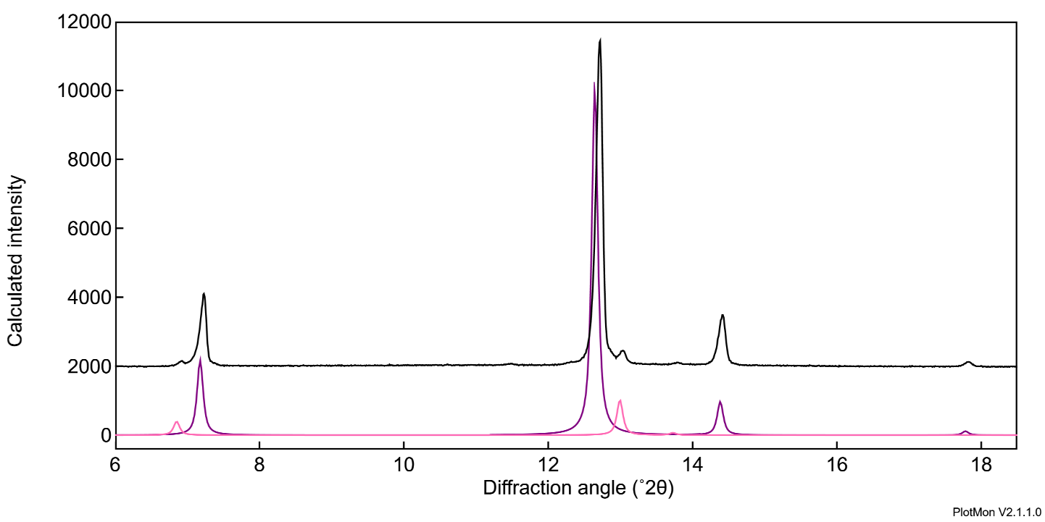

Conclusion
The conversion of theophylline Fm to FII upon heating is strongly dependent on the relative humidity. Our VT,VRH-PXRD in-situ observations of the dehydration of theophylline monohydrate investigated the temperature-relative humidity phase diagram of theophylline and produced – in a matter of a few experiments – forms II, III, V, and I*.
It should be noted that theophylline is a well-studied molecule and the available literature provided guidance in the design of the experiments (DoE) and allowed for a deep level of interpretation of the data. Generally, when newly developed molecules are under study, orthogonal thermal techniques such as dynamic vapor sorption, differential scanning calorimetry, and thermal gravitational analysis provide guidance for the DoE. Furthermore, computational data processing techniques such as indexing of the powder patterns may be used to help interpret the results when reference patterns are not readily available. Nevertheless, we demonstrated VT,VRH-PXRD is a powerful and relatively effective technique to discover polymorphs involved in phase transitions and explore the thermodynamic T–RH phase diagram.

References
- Neelima V. Phadnis and Raj Suryanarayanan, J.pharm.sci. 86(11) (1997) 1256–1263; Form I, I*.
- Jaidev S. Tantry, Jitesh Tank, Raj Suryanarayanan, J.pharm.sci 96(5) (2007) 1434–1444; form A*.
- Raitis Bobrovs, Linda Seton, Nicola Dempster, CrystEngComm 17 (2015) 5237–5251; Form IV.
- Dikshitkumar Khamar, Ian J. Bradshaw, Gillian A. Hutcheon, and Linda Seton, Cryst. Growth Des. 12 (2012) 109–118.
- Eduardo Maia Paiva, Qi Li, Adam J. Zaczek, Claudete F. Pereira, Jarbas José Rodrigues Rohwedder, and J. Axel Zeitler, Mol. Pharmaceutics 18(9) (2021) 3578–3587; Form III.
- Anders S. Larsen, Mark A. Olsen, Hadeel Moustafa, Flemming H. Larsen, Stephan P. A. Sauer, Jukka Rantanen, Anders Ø. Madsen, CrystEngComm 21 (2019) 4020–4024; Form III and putative transition phase T1.
- V.M. Dyulgerov, L.T. Dimowa, K. Kossev, R.P. Nikolova, B.L. Shivachev, Bulgarian Chemical Communications, 47(1) (2015) 311–316; form V.
- Mark D. Eddleston, Katarzyna E. Hejczyk, Erica G. Bithell, Graeme M. Day, and William Jones, Chem. Eur. J., 19(24) (2013) 7883–7888; form VI.
- Mark D. Eddleston, Katarzyna E. Hejczyk, Andrew M. C. Cassidy, Hugh P. G. Thompson, Graeme M. Day, and William Jones, Cryst. Growth Des., 15, (2015) 2514–2523; form VII.
- D. June Sutor, Acta Crystallographica, 11, (1958) 83–87; monohydrate.
- Cletus Nunes, Arumugam Mahendrasingam, and Raj Suryanarayanan, Pharm. Res. 23(10), (2006), 2393–2404.

Contact Information :

Triclinic Labs
2660 Schuyler Ave., Suite A
Lafayette IN 47905
USA
www.TriclinicLabs.com
rfi@triclinicabs.com

